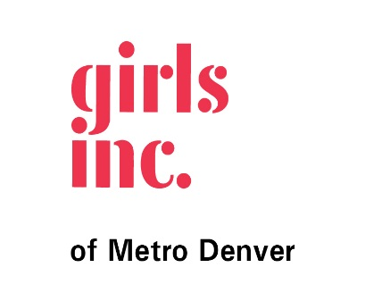

GiRlS Inc. of metro Denver scholarship PROGRAM
Recommendation Letter Request
To Whom It May Concern:
________________________ is applying to the Girls Inc. of Metro Denver Scholarship Program, which awards scholarships annually. These scholarships recognize the leadership and accomplishments of young women who have participated in Girls Incorporated of Metro Denver programs. The purpose of the scholarship program is to make post-secondary education accessible by offsetting the financial costs of higher education. Our hope is that our scholarships will inspire young women to succeed in school, become leaders and contribute to their communities.
Part of the scholarship selection process requires a letter of recommendation from someone in an educational, work, or volunteer setting who can speak to the applicant's abilities and qualifications. By receiving this form, the applicant is requesting that you provide answers to the following questions with your signature and stated relationship to the applicant. Your letter is a critical part of our selection and awareness process. Please answer the attached questions in a separate typed letter:
      - How long have you known the applicant and what is your relationship to her?
      - How has this person demonstrated leadership skills? Please give specific examples.
      - How has this person been a positive role model for others?
      - How would you describe this person’s character?
In addition, please include your name and title in the letter and a brief description of how you know the applicant. All questions should be addressed in your recommendation. The completed form must be returned to the applicant in a sealed envelope for submission with her application package. All applications are due by 5:00 pm on February 1, 2019. If needed, you can find the recommendation request form on our website at www.girlsincdenver.org
On behalf of Girls Incorporated of Metro Denver, we thank you for your time, interest and participation in this process. Thank you for helping to inspire our girls to become strong, smart, and bold.
Sincerely,
The Girls Inc. of Metro Denver Scholarship Program

