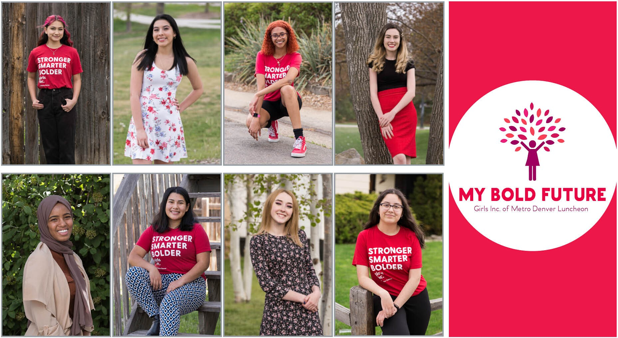

GIRLS INC. OF METRO DENVER

Event Captain Toolkit

MY BOLD FUTURE

Virtual Campaign
August 10-14

VIP Scholar
Panel
August 13
4:00 pm

Dear Girls Inc. Supporter,

Thank you for being an Event Captain for Girls Inc. of Metro Denver’s first-ever, virtual My Bold Future event. Held August 10th through 14th, this year’s My Bold Future is a week-long campaign that will highlight Girls Inc.’s work and mission, celebrate our 2020 scholarship winners, honor three inspiring Champions for Girls, and recognize all those who contribute to our goal of inspiring all girls to be strong, smart, and bold!

As an Event Captain, you are the key component of the event’s success by inviting people in your professional network, friends, and family to learn more about Girls Inc.’s work, directly from the girls we serve. While our event is a fundraiser, it is also a unique opportunity for you and your guests to be inspired by truly amazing stories of the lives impacted by Girls Inc. of Metro Denver’s comprehensive, whole-girl programs.

At this year’s virtual My Bold Future, your guests will join a community of supporters committed to helping girls overcome barriers to success and achieve their goals. Your guests will receive daily video content celebrating girls’ achievements, recognizing local Champions for Girls, and highlighting our Girls Inc. programs, partners, and 2020 scholars. Additionally, all guests will receive an invitation to our VIP Scholar Panel where attendees can learn and engage with girls from the comfort of their own home! Lastly, all attendees will have an opportunity to enter the Girls Inc. of Metro Denver prize drawing. Packages are being finalized, but lucky winners could win first class airfare for two, a weekend escape to the mountains, and more!

Thank you again for contributing to making our event a success by reaching out to those you know and inviting them to this wonderful event!

Sincerely,
Sonya Ulibarri President & CEO

WHAT WHEN

WHY

HOW

AUDIENCE
Event Overview
My Bold Future: A Virtual Campaign.

Monday, August 10 through Friday, August 14. Video content will be released daily at noon. Content will be released directly to registered guests’ inboxes. A VIP Scholar Panel will be held Thursday, August 13 at 4:00 pm. The VIP Panel will be hosted virtually, and a link and invitation will follow. Visit www.girlsincdenver.org for event information.

My Bold Future is Girls Inc. of Metro Denver’s signature fundraising luncheon to support our mission to inspire all girls to be strong, smart, and bold!

The goals of this event are to:
- Share the work and impact of Girls Inc. of Metro Denver
- Increase awareness and ongoing encourage engagement
- Raise money through virtual fundraising and prize drawing sales

The event is a unique opportunity for sponsors, donors, volunteers and community members to learn about the personal impact that Girls Inc. of Metro Denver has for girls and families and invite them to become involved.

Registration for guests is free and easily done online. Guests will have an opportunity to make a donation and purchase tickets for the prize drawing.

The virtual campaign will be directed at noon each day to over 1,000 of Girls Inc. of Metro Denver’s corporate and community partners, individual donors, families, and Girls Inc. girls. All material will be released on delay to the larger community via social media and on Girls Inc. of Metro Denver’s website.

Table Host 101
Being an Event Captain is one of the most impactful ways you can influence the success of Girls Inc. of Metro Denver’s fundraising efforts and visibility in the community. An Event Captain invites people to be a guest at the first-ever, virtual My Bold Future where they will learn more about the work that Girls Inc. has been doing in our community for the past 38 years. Each host has the opportunity to invite 10 or more guests.

Family, friends, neighbors, and colleagues make excellent guests. The event is free to you and your guests and everyone will have the opportunity to make a donation and/or purchase tickets for the prize drawing. Event Captains do not have to ask for money and there is no minimum or maximum required for donations or purchase of prize drawing tickets.

Inviting & Following Up with Guests
The best invitation is a personal one. Invite your guests in person by phone or e-mail. A sample email template has been included in this packet for your convenience. Please plan to register your guests with emails to Girls Inc. of Metro Denver by Monday, August 1 or sooner. Complete your registration online here. Once you’ve completed your table registration you will receive a registration receipt. You can make changes after you’ve submitted your table using the link provided in your registration receipt.

When you register, you can choose to receive a Girls Inc. of Metro Denver Event Box. The event box will include items to help you enjoy the virtual VIP scholar panel. Items may include a Girls Inc. wine glass and cheese board, sweet treats to enjoy, and bubbly beverages!

Please do not hesitate to reach out to Jenny Martin with any questions or requests for assistance at jmartin@gidenver.org.

Event Week
Beginning Monday, August 10 your guests will receive a daily email from Girls Inc. of Metro Denver. You and your guests will hear from our President & CEO, Sonya Ulibarri, 2020 Girls Inc. Scholars, Champion for Girls, and Girls Inc. Alumna. Share your participation on your social media accounts using resources in this packet.

Prize drawing tickets are currently available for purchase at www.girlsincdenver.org. Tickets can be purchased up until noon on Thursday, August 13th. Purchase your prize drawing tickets here. Since the event is virtual, Girls Inc. of Metro Denver will submit your tickets into the drawing on your behalf.
Tune in on August 14th at noon to find out if you’re a winner!

After the Event
Please call your guests a day or two after the event to thank them for participating. Our development team can help with any follow up as needed.

Table Hosts Tips & Important Dates

Make contact right away. Make a list of 15 prospects right now! Decide what communication will work best for you and your prospects. This could include an initial phone call followed by an email or note. Don’t wait -- start today!

Make it personal. Let people know your connection to Girls Inc. of Metro Denver. Why do you care about our programs? In your opinion, how can Girls Inc. benefit from greater philanthropy or community involvement? Your story often means as much to your friends and colleagues as it does to you.

Communicate expectations. Be up front that the virtual My Bold Future and VIP Scholar Panel are free to attend, and we hope they will be able to make a contribution during the weeklong campaign. No gift is too small. Remind them there will also be a prize drawing they can participate in to help contribute.

Follow up with people you don’t hear back from. Just because they don’t follow up with you doesn’t mean they’re not interested. People get busy and forget to RSVP even though they plan to participate.

Send two reminders to attendees. Email your guests that you look forward to a wonderful week learning from Girls Inc. girls the week of August 3rd. Send a second reminder about the VIP Scholar Panel on August 12th. Remind guests that all details will be sent directly to them from Girls Inc. of Metro Denver. You may need to include a note to check their spam folders if a guest is not seeing emails from us.

Have fun! This is an event to celebrate the work we all do for Girls Inc. of Metro Denver and an opportunity to share your passion for our organization with your friends, family, and colleagues. You can use the social media resources in this packet to share online!

Aug.
Aug.
Aug.
15
13
10- 14
Aug. 1
Today!

Start inviting guests
You can use the sample email provided.

Remind guests that prize drawing tickets are available for purchase now. Participation not required!
Registration Due Date
All guests with email addresses should be registered with Girls Inc.

Complete your registration online here.
Virtual My Bold Future Week
Registered guests will receive a daily email from Girls Inc. of Metro Denver with exciting content featuring girls, awardees, and staff.
Virtual VIP Scholar Panel, 4:00- 5:00 pm Guests will hear directly from the 2020 Scholars and have a chance to ask their own questions.

If you’ve chosen to receive an event box, it will be delivered to you by this date.
Thank your guests
Call and/or email your guests to thank them for participating and supporting Girls Inc. of Metro Denver!

Sample Email Inviting Guests to Attend

Dear/Hello_____ ,

I’m writing to invite you to an inspiring event for Girls Inc. of Metro Denver, an organization that means a lot to me. I’ve been supporting/involved with Girls Inc. of Metro Denver for _____ years. This year I’m hoping you will join me for the first-ever, virtual My Bold Future Event to hear how Girls Inc. impacts the lives of girls in our community.

(Give a personal reason why Girls Inc. is important to you)

As my guest, each day at noon, you will receive virtual content videos beginning Monday, August 10th, concluding Friday, August 14th. The virtual content will be brief videos celebrating the success of Girls Inc. of Metro Denver’s programs, honoring partners, and awarding over $52,000 in college scholarships to Girls Inc. girls! You can also purchase prize drawing tickets here until noon on August 13th. Prize drawing winners could walk away with first class airfare for two, a weekend escape to the mountains, a Denver Date Nights, and more.

There is no cost to participate, but I need to register you. Please simply reply to this email and I will add you to my group! The campaign is sure to be inspiring and I hope you can join me.

(Thank you and personal note)

Additional Information:
Girls Inc. of Metro Denver inspires all girls to be strong, smart, and bold through life changing programs and experiences that help girls navigate barriers and reach their full potential. Girls Inc. of Metro Denver provides year-round academic-achievement and skill- building programs that are delivered by trained, mentoring professionals in a positive all-girl environment.

Each year, Girls Inc. of Metro Denver serves over 2,200 girls between the ages of 6 and 20 from diverse backgrounds. Programs cover themes such as science, technology, engineering and math (STEM) education, pregnancy and drug abuse prevention, entrepreneurial exploration, leadership development, and healthy living.

Social Media Resources

We know that as an Event Captain you are eager to share your excitement for My Bold Future and your connection to Girls Inc. of Metro Denver’s work. To make this simple, we have created a few resources for your use. You can use these resources as is, or we encourage you to personalize your posts. Additionally, we hope you will share our posts throughout the week of August 10th to help spread the word to your larger community. If you aren’t already following us, please use these links to do so!
‌ ‌ ‌ ‌

You can download these images here! The copy uses our Facebook and Instagram handle. If you’d like to share on Twitter, please use @girlsincdenver

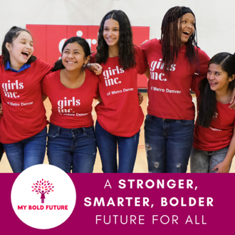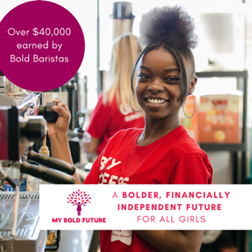
I’m thrilled to support Girls Inc. of Metro Denver’s #MyBoldFuture. Follow @GirlsIncMetroDenver to learn about how we serve girls in our community! #StrongerSmarterBolder
Together we are #StrongerSmarterBolder. Join me in supporting @GirlsIncMetroDenver virtual #MyBoldFuture fundraiser. Go to www.girlsincdenver.org to learn more!
Bold Beans, @GirlsIncMetroDenver social enterprise coffee shop, is just one of the many incredible programs that help girls achieve their goals. Join me in supporting this girl-led small business! #StrongerSmarterBolder. www.girlsincdenver.org

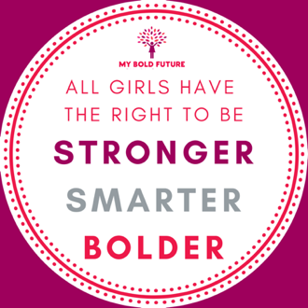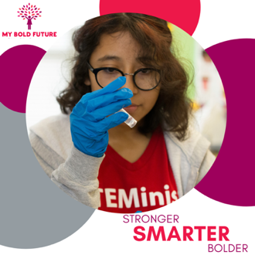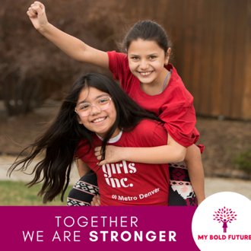
Unfortunately, gender inequity persists, and girls of color are especially vulnerable. Join me and let’s work toward a #StrongerSmarterBolder future for all girls! Follow @GirlsIncMetroDenver and join the virtual #MyBoldFuture August 10-14 to learn more!
Girls Inc. girls are more likely to believe they can handle harder math and science content. That is vital to getting more girls in STEM, a cause I am passionate about. Join me August 10-14 for @GirlsIncMetro Denver virtual #MyBoldFuture to learn about their incredible programs and how we can all support girls in STEM.
At Girls Inc. we know that girls are born innately strong. Along the way the world chips away at their strength. Together we can repair that and make a #StrongerSmarterBolder future. #MyBoldFuture

